**ELP Mini Project Proposal**

Group Members:

|  |  |
| --- | --- |
| Aditya Jaiswal | 2023ES10512 |
| Kalyani Charan | 2023ME10452 |
| Sarthak Garg | 2023ES11065 |

Topic Chosen - Project 8: Motor speed control (2):

Introduction:

The aim of the project to make a circuit that is capable to control the speed of a DC motor. A 12 volt 0.5 ampere permanent magnet DC motor has been used. A 555-timer has also been used to apply pulses (and create a pulsating supply) to the DC motor and control its speed. The timer cannot supply power to the motor by itself, you will need to use a BJT (2N2222) and a diode (DN4007) for this purpose.

We need to demonstrate the motor running at (a) rated speed, and (b) half the rated speed.

Components:

* Power Source
* 2 10 kohm resistances
* Variable Resistance of 100 kohm
* 3 1N4007 diodes
* 1 47 nF capacitor and 1 10 nF capacitor
* 555 Timer
* 12 V DC Motor
* Bipolar Junction Transistor
* Breadboard

Circuit Diagram:

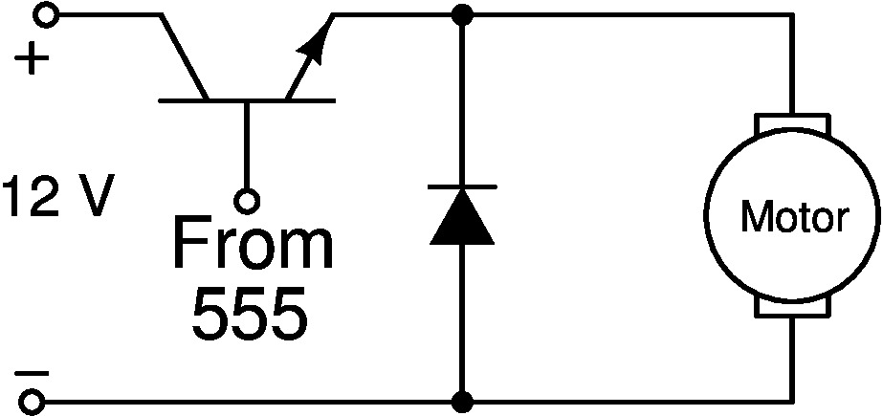

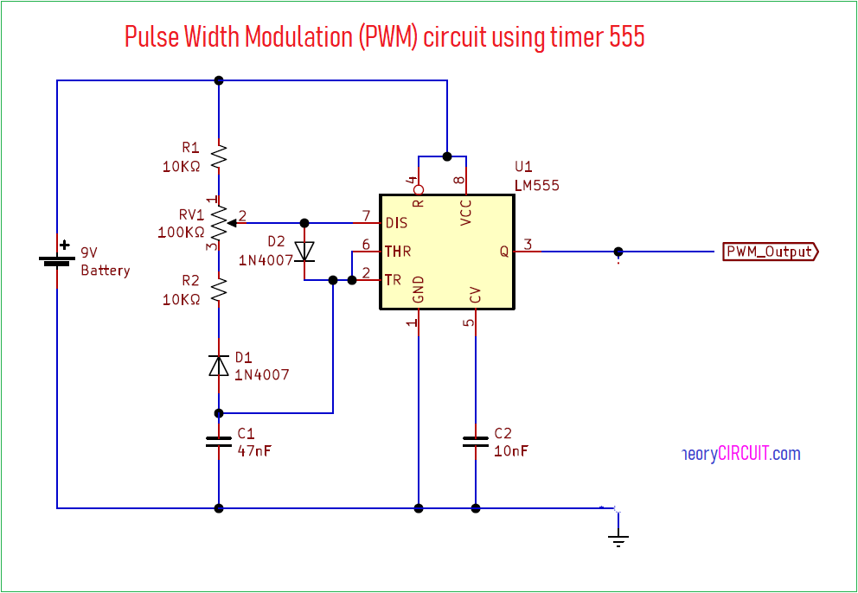

Working Principle:

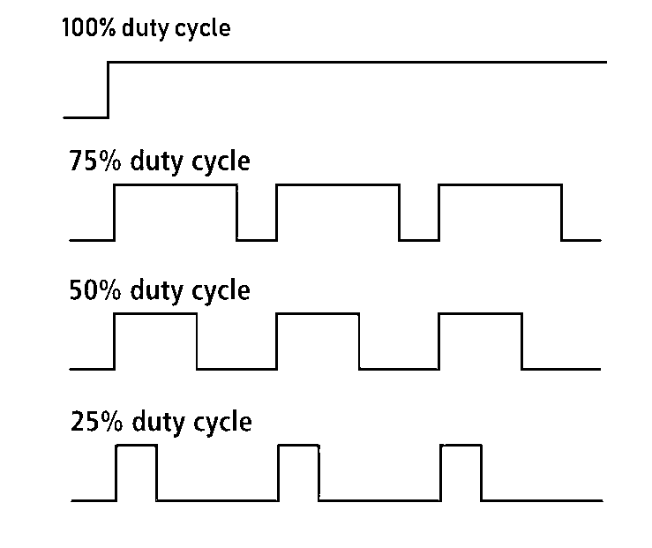This Pulse width modulation circuit using timer IC 555 designed to deliver PWM signal at output with different level of duty cycle. Here IC 555 configured in [astable multivibrator](https://theorycircuit.com/calculator-for-electronics/ic-555-timer-astable-multivibrator-circuit-calculator/) mode and output PWM obtained for continuous square pulse.

Width of Pulse is varies according to the amplitude of input signal, when the amplitude reaches the highest value then pulse duty cycle increases to maximum level by the way when the input signal amplitude reaches the lowest point then pulse width decreases to minimum level.

By varying the timer element RV1 we can change the pulse width modulation output frequency, here the indicates the duty cycle of output PWM with fading effect.

**Bill of Materials**

|  |  |  |
| --- | --- | --- |
| **S. No.** | **Description** | **Quantity** |
| 1. | Power Source | 1 |
| 2. | 10 kohm resistance | 2 |
| 3. | Variable Resistance | 1 |
| 4. | 1N4007 Diodes | 3 |
| 5. | 47nF capacitor | 1 |
| 6. | 10 nF capacitor | 1 |
| 7. | 555 Timer | 1 |
| 8. | 12 V DC motor | 1 |
| 9. | Breadboard | 1 |
| 10. | Bipolar Junction Transistor | 1 |